November 7, 2013 F/NWR-5

**FILE MEMORANDUM**

**FROM:** Gary Fredricks

**SUBJECT:** A Review of the 2013, The Dalles Dam Attraction Spill “Test”

On September 14 through 16, the Action Agencies agreed to try a limited amount of daytime spill to help reduce adult fish crowding in the East Ladder at The Dalles Dam. Flow in the amount of three kcfs was spilled for seven hours (0600 – 1200) from the north spillbay with the idea of pulling more fish to the North Ladder. The action was stopped after three days because the agencies deemed the action ineffective. While the effort was ineffective in relieving the East Ladder crowding, I believe the following data fail to support any assessment that the effort was not effective in moving fish.



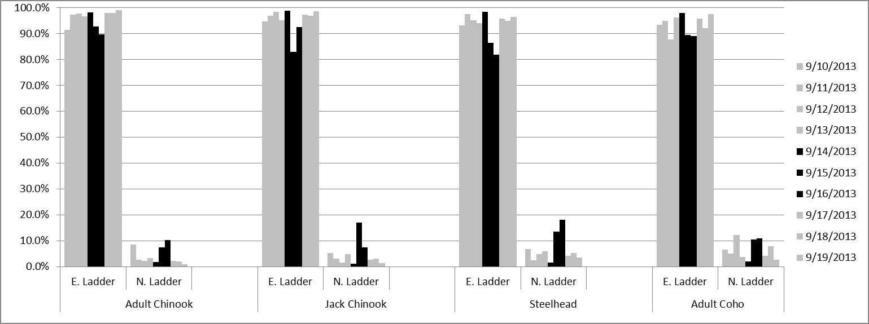

I believe the data clearly show what appears to be a response in ladder passage at the North Ladder as a result of the additional spill. The spill amount was quite small compared to the total river flow and the duration of the additional attraction spill was short and started when the fish would normally have already started entering the ladder systems. Even so, it appears that after a day lag time, several species of salmon did respond to the additional spill. This test is was certainly too short and too limited to provide any conclusive information. However, these results do indicate that any claims of failure may be unfounded and they also leave the question of whether a more determined effort would have been successful in reducing the east ladder crowding situation. A comparison of these data with the radio tracking data collected this year may shed additional light on this issue.